**SHOPPING FOR A VEHICLE? MCj03985230000[1]MCj03985230000[1]MCj03985230000[1]**

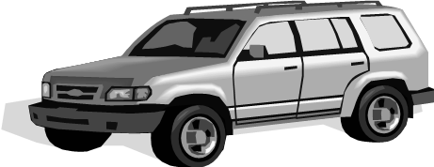

**Sunbury Motor Company** provides us with a wonderful opportunity to raise more funds for the shelter. They’ve redirected a large portion of the monthly advertising budget to local charitable donations. They will donate $225 to designated non-profit organizations for each vehicle (new or used) sold through a referral program. New makes sold include Ford, Lincoln, Kia, and Hyundai. As mentioned, used vehicles are included in this offer as well.

If you and/or your friends and family are considering a new or used car and you think **Sunbury Motor Company** may be the dealer of choice, please visit the Mostly Mutts website at [www.mostlymuttsonline.com](http://www.mostlymuttsonline.com) and this referral ad can be found under the Support Us tab then drop down to Ways To Help. Look for the **Sunbury Motor Company** advertisement and you will be able to find a **link to print this referral ad**. You can also contact Cindy Shamp at (473-1029) or [mostlymuttsonline@gmail.com](mailto:mostlymuttsonline@gmail.com) if you need help. This referral ad will enable Mostly Mutts to receive the charitable designation. This $225 is not an add-on to your purchase price. You don’t present the ad until your deal is completed, **BUT the ad must be given at that time for Mostly Mutts to receive the donation.**

**Many thanks to Tom Mertz & Sunbury Motor Company!** Since the start of their referral program, over $21,000 has been contributed to Mostly Mutts. We are very grateful!

